

***STUDENT NAMES:***

***SHOAIB AHMED(10621)***

***NOORMA IQBAL(10529)***

***SUBJECT: "DCN SEMESTER PROJECT"***

***UNIVERSITY NETWORK SYSTEM (UNS)***

***INTRODUCTION:***

University Network System, in which we will have 6 departments, name are as follows(AVIONICS,CS,ERP,MATHS,ENGLISH,ENGINEERING) Each department have PCs (Labs & Rooms, etc). All departments have there own statics IPS and are connected through routers and those routers are connected to a main router that is responsible for the communications of whole networks. Then we have connected two wireless routers one with CS department and the other one with ENGINEERING department.Then we have two laptops connected wirelessly with two wiresless router that are connected to the network so that we can send and recieve data. We have implemented Routing Information Protocol on complete network which finds the best short route to reach the destination whenever packet (Data & IP information) passed or sent.

***OBJECTIVE:***

The main objective of this network is to update the existing network and also enhance its capabilities and increase the flexibility of the network which will eventually provide good security.

***NETWORK TOPOLOGY:***

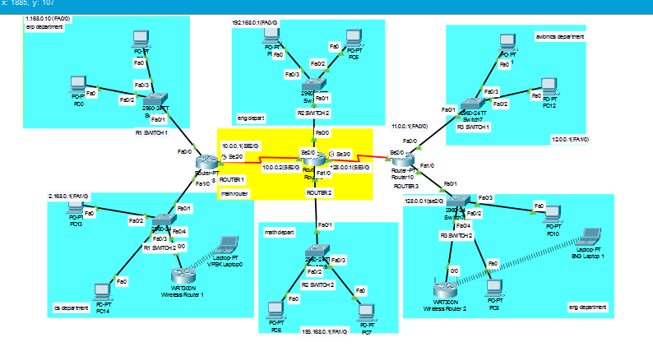

***RIP ADDRESSING:***

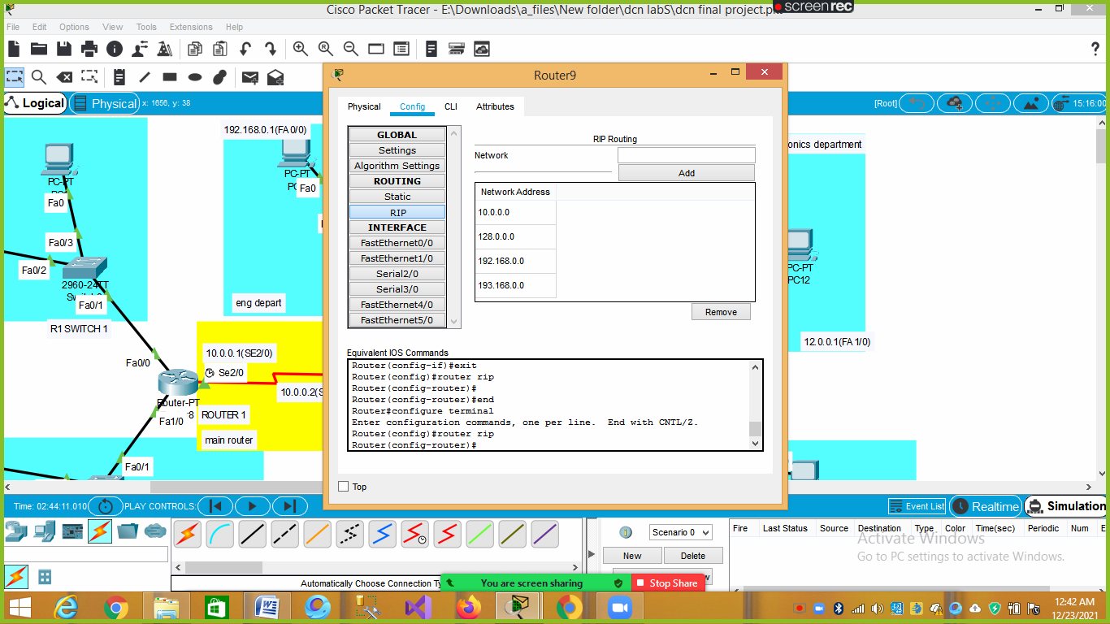

***IP ADDRESSING:***

|  |
| --- |
| **AVIONICS DEPARTMENT (12.0.0.1)** |
| **ENGLISH DEPARTMENT (192.168.0.1)** |
| **ENGINEERING DEPARTMENT (128.0.0.1)** |
| **ERP DEPARTMENT (1.168.0.10)** |
| **MATH DEPARTMENT (193.168.0.1)** |
| **CS DEPARTMENT (2.168.0.1)** |

***TESTING :***

**ERP DEPARTMENT**

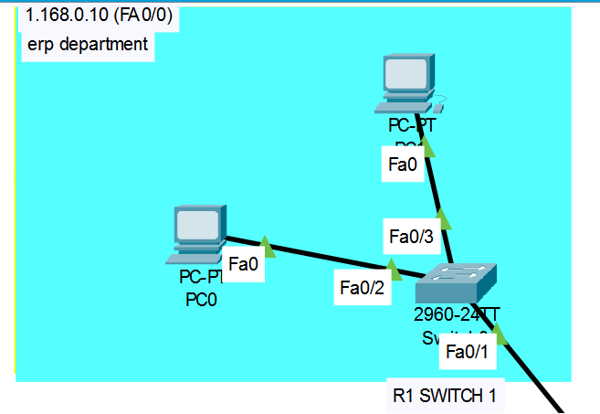

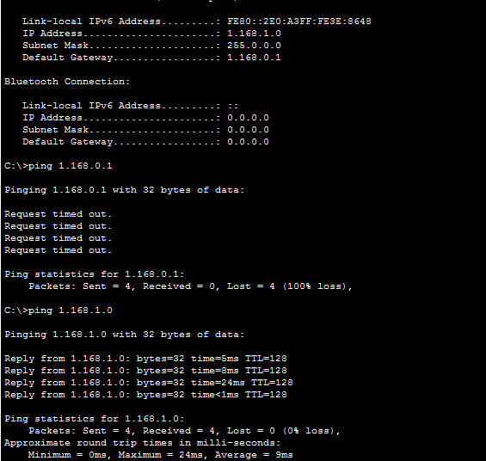

**CS DEPARTMENT :**

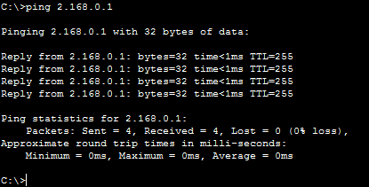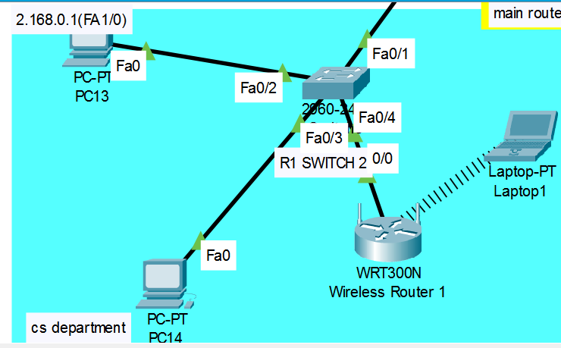

**MATH DEPARTMENT**

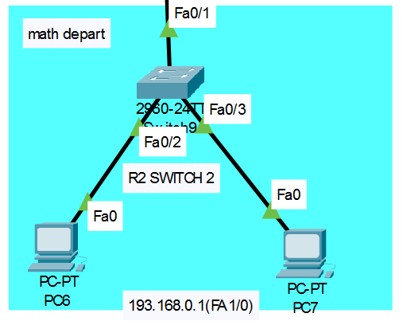

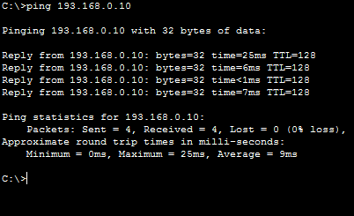

**ENGINEERING DEPARTMENT**

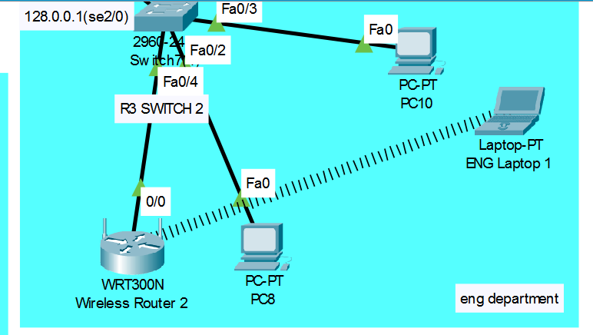

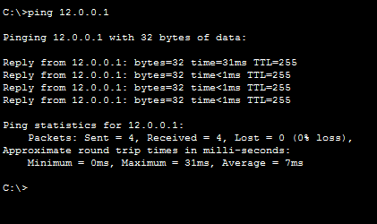

**AVIONICS DEPARTMENT**

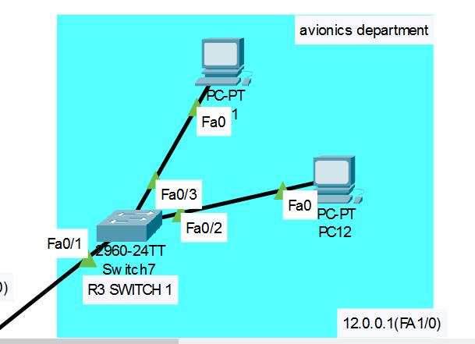

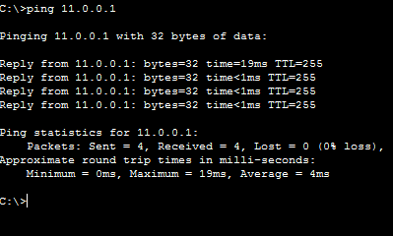

**ENGLISH DEPARTMENT**

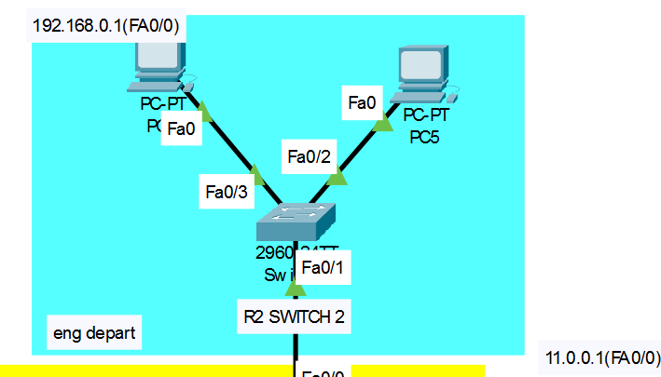

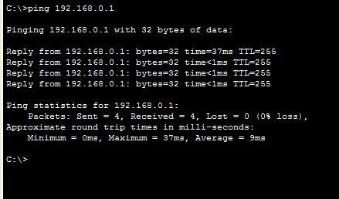

**Wireless Laptop 1 SETUP(DHCP):**

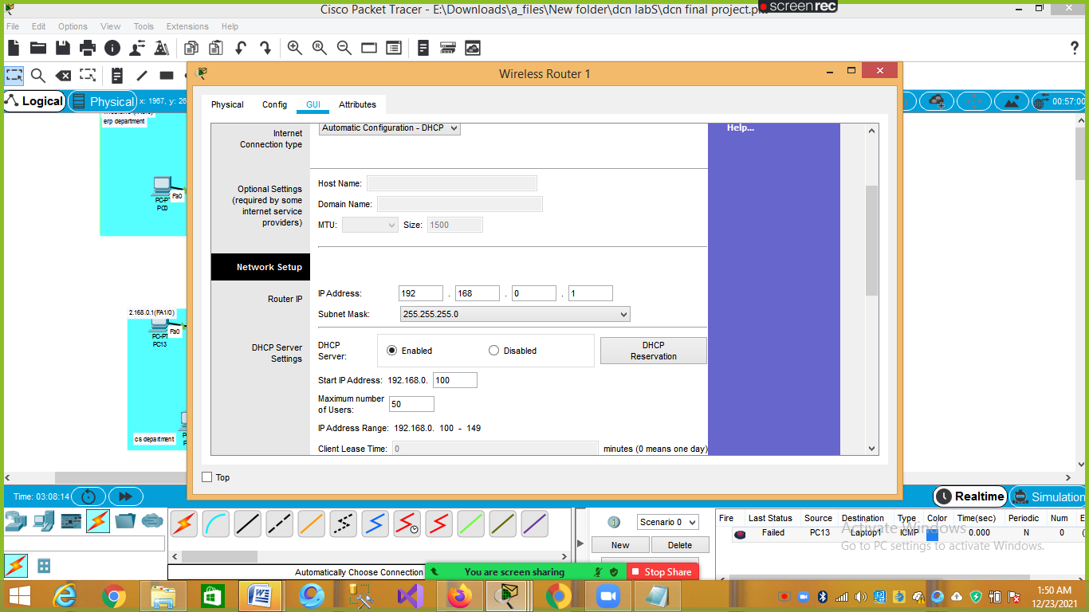

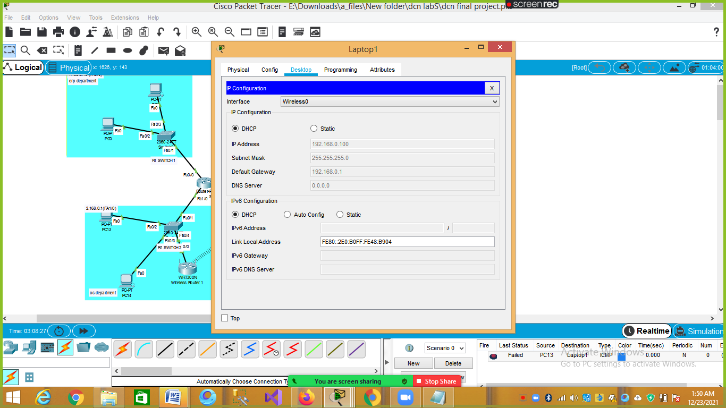

**Wireless Laptop 2 SETUP(DHCP):**

